**Project Handbook**

Contents

1. Introduction 2
2. Project Specification 2
   1. Objective 2
   2. Scope 2
   3. Deliverables 2
   4. Technologies 3
   5. Timeline 3
3. Agile methodology 3
   1. Use Stories/Cases 4
   2. Example Use case specifications 6
   3. Product backlog-Rating the use case based of the importance of the website 13
4. Database design 14
   1. Spreadsheet 14
   2. ERD diagram: - represents the relationship between the tables in an understandable and appealing way 16
5. Mood Board- represents the colour scheme the product owner wants for his website 17
   1. Draft 1: Modern Theme 17
   2. Draft 2: Vintage theme 19
6. Wireframes- Having the idea how the website may look and work with it 21
   1. Desktop View: 21
   2. Phone View 22
7. Prototypes- first attempt at developing the website 23

7.0 Landing Page:

7.1 Landing Page 2:

7.2 Final Landing Page:

1. Website design- Final website draft 24
   1. Product Page Draft 2 25
   2. Admin page Draft 3: 26

# Introduction

Welcome to the project handbook for McFadden, our online marketplace dedicated to musical instruments. As an e-commerce venture specializing in musical instruments, McFadden is driven by a commitment to deliver the highest quality instruments, imbued with unique musical styles, and backed by exceptional customer service to guarantee utmost satisfaction. This handbook serves as a comprehensive guide to our website, offering insights into its development, database structure, sign-in processes, and account creation procedures.

McFadden has been meticulously developed using a combination of HTML, CSS, and PhP, featuring a robust database spreadsheet normalized for efficient data management. We've employed wireframes to design both desktop and mobile views, and a mood board has guided the color scheme to create an engaging and immersive user experience.

Throughout the developmental journey, we've adhered to the Agile methodology, emphasizing flexibility and continuous improvement. This handbook provides a detailed overview of the McFadden project, encompassing its objectives, design concepts, and the development processes. Additionally, it offers valuable resources and guidelines for the ongoing maintenance and enhancement of the platform.

Whether you're a user exploring our diverse range of musical instruments or a team member contributing to the project's evolution, this handbook stands as your go-to resource for understanding the core of McFadden and ensuring its sustained success in the realm of musical exploration.

# Project Specification

## Objective:

We envision McFadden as a prominent online marketplace for budget-friendly musical instruments, offering a diverse range of high-quality and trendy musical items at affordable prices and available online . The primary goal of McFadden is to democratize access to premium musical instruments, making sure that everyone, regardless of their budget, can explore the latest musical trends and discover unique pieces that resonate with their personal style.

Our primary challenge is to create a seamless and innovative front and back-end website that aligns with this vision. Driven by our commitment to customer satisfaction and fueled by our passion for music, we are dedicated to developing an advanced website for McFadden that caters to the diverse demands of our customers.

Before implementing any changes, we prioritize consulting our clientele to identify potential issues and thoroughly understand their requirements. This approach ensures that McFadden evolves in a way that not only meets but exceeds the expectations of our valued customers, creating an enriching and affordable musical experience for all.

## Scope:

The McFadden website is designed to showcase an extensive array of musical instruments catering to men, women, and children, offering a diverse selection of instruments such as guitars, keyboards, drums, and more. Our platform boasts essential functionalities, including a search feature for easy navigation, a filter function to refine product searches, and a convenient shopping cart feature for seamless transactions.

Customers will have the option to create accounts, allowing them to save preferred instruments to their carts and conveniently review their purchase history. Our commitment to providing a user-friendly and personalized experience ensures that McFadden becomes the go-to destination for music enthusiasts of all ages, offering not just instruments but a comprehensive musical journey.

## Deliverables:

* + - A fully functional and responsive e-commerce website
    - A customer registration and login system
    - A shopping cart feature
    - Inventory management (Add/Update/Delete)
    - A customer account management system

## Technologies:

In the endeavor to create our McFadden website, we'll employ a combination of essential technologies to ensure a robust and dynamic platform. For the front-end structure and styling, we'll utilize HTML for the webpage structure and CSS to craft a distinctive and visually appealing appearance. Moving on to the back-end development, we'll implement the server-side logic using PHP in conjunction with the CodeIgniter framework for a structured and efficient development process. Notepad++ will be our text editor of choice for coding, providing a lightweight and feature-rich environment for web development. For the database management aspect, we'll integrate PhpMyAdmin with CodeIgniter to establish a secure and organized database structure. This involves connecting the PhpMyAdmin database to our CodeIgniter project, facilitating seamless data population and retrieval.

## Timeline:

The anticipated timeline for the project's development spans of 3 month. Regular check-ins and progress updates are scheduled with both the Scrum Master and Product Owner. The provided project specification offers a concise yet comprehensive glimpse into the project's goals, scope, deliverables, technologies, and the condensed 3-month timeline.

# Agile methodology:

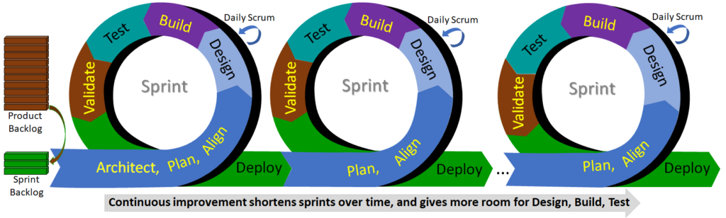

The Agile Methodology represents a project management approach that places a premium on flexibility and collaboration throughout the development process. This methodology entails frequent, short iterations known as "sprints," during which the team produces a tangible output and presents it to the customer for feedback. The feedback received is then employed to strategize tasks for the next sprint, fostering a continuous cycle of improvement and adaptation. In essence, the Agile methodology emphasizes flexibility, collaboration, and ongoing enhancement, empowering teams to deliver a high-quality product in an efficient timeframe. This methodology is the cornerstone of our approach to creating the client's website. Our team has adeptly embraced and leveraged this methodology to our advantage in this project. To provide a tangible illustration of our utilization of this method, we will showcase it through components such as the project backlog, functional requirements, use cases, mood boards, and more

4

# Use Stories/Cases:

Within the project, we incorporated four distinct use cases, each addressing core functionalities: Add, Delete, and Update actions for products, staff, members, and categories. Additionally, we implemented essential user interactions such as Login, Register, and cart functionality. A specific example of a Use Case is detailed below:

**Use Case Name: Add New Product**

Use Case Description: This use case allows the admin to add a new product to the online store.

Participating Actor(s): On-line Admin

Entry Conditions: The admin must be logged into their account and have access to the product management feature.

Flow of Events:

1. The admin selects the "Add New Product" option from the product management menu.

2. The system responds by displaying a form for the admin to enter the product details.

3. The admin fills out the product details and selects the "Add Product" button.

4. The system responds by generating a unique product ID, adding the product to the database, and displaying a message to the admin indicating that the product has been added successfully.

Exit Condition(s): A new product has been created and added to the online store.

Alternatives:

- If the admin is not logged into their account, the system prompts them to do so before they can add a new product.

- If the admin enters an invalid input or leaves a required field blank, the system displays an error message and prompts the admin to correct the input.

Exceptions: None.

Second Step: Product Backlog

* + - It's a form template which allows to rate the tasks from very important to less important.
    - Teams can use the product backlog to avoid wasting time debating whether an option is valuable or not based on limited information

Third Step: Mood Board

* The determination is made in collaboration with the product owner, aligning with their desired look and feel for the website.
* This process provides developers with insights into the preferred color scheme specified by the product owner.

Forth Step: Wireframe

* The wireframe serves as a preliminary visualization to capture the customer's preferences for their website. The team, led by the Scrum Master, maintains consistent communication with the customer to ensure satisfaction with the wireframe. In cases where the customer expresses discontent, the team revisits the drawing board to create a new draft aligned with the customer's expectations.

Sixth Step: Prototype

* It serves as a tool to visualize the product owner's ideas, enhancing comprehension of intricate details.
* Following the completion of the prototype, software developers present it to the product owner, soliciting valuable feedback for refinement.

Seventh Step: Design

* Emphasizing design was paramount for the front-end users, prompting frequent discussions with customers to align with their intentions.
* The website aimed to appeal to a broad target audience spanning different age groups. Consequently, the selection of bright/neutral colors became crucial to cater to a diverse demographic.
* Initially, our prototype featured brighter colors, raising concerns that it might deter some users, possibly indicating a focus on a younger audience. This prompted a necessary update to the website.
* In our revised approach, we opted for modern and vintage color scheme. This choice not only accentuates the page's simplicity but also exudes a sleek and professional aesthetic, appealing to users of all ages and demographics.

# -Rating the use case based of the importance of the website:

# Database design:

# Spreadsheet:

In the design of our database spreadsheet, we used phpMyAdmin to link all the tables together. It allowed us to understand how the data is organized and how it is related to other data.

We used PhpMyAdmin to create a clear and logical link between all the tables in the database using an ERD diagram, this helped us to ensure that all the data was properly organized and easy to access. This was especially important since our website was supposed to be able to handle a large amount of data and needed to be efficient. We have a **member table** that stores the data of users who wants to sign up for the membership this membership will allow them to purchase products. The **username/email** table will store the login details of the users or the staff. The Staff table will store the staff members details which will allow them to access the admin page and edit the products. The **product** table will store the products details such as the BarCode, price, quantity. The **order** table will store the order details when the user purchases a product.

* 1. ERD diagram: - represents the relationship between the tables in an understandable and appealing way:

We assigned priority, status, sprint, and various other attributes to each user story, enabling us to effectively manage and monitor the development process. The priority attribute served as a guide in identifying the user stories critical to the website's success, ensuring their prioritized completion. The status attribute facilitated continuous tracking of each user story's progress, distinguishing between completed, in-progress, and yet-to-start tasks. The sprint attribute played a pivotal role in organizing user stories into task groups, ensuring completion within designated timeframes. This structured approach significantly contributed to the streamlined and efficient development of the website.

By employing user stories and implementing attributes such as priority, status, sprint, and others, we enhanced our ability to manage and monitor the development process, ensuring the website aligned seamlessly with user needs. This method allowed us to maintain focus on the project's objectives, enabling us to prioritize essential features and functionalities crucial to the website's success. Through this approach, we ensured a systematic and goal-oriented development process, guaranteeing that the final product would effectively meet the requirements and expectations of its users

# Mood Board- represents the colour scheme the product owner wants for his website:

## Draft 1: Modern Theme:

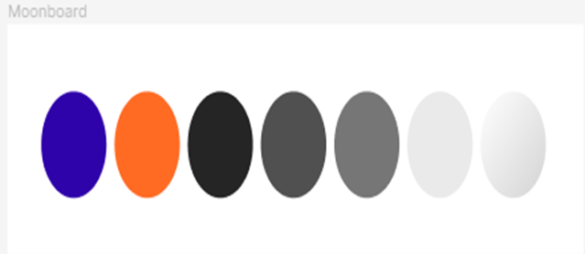

Our group collectively opted for two themes: modern and vintage. In response to this, we decided to explore both modern and vintage themes, presenting a diverse range of options. By doing so, we aim to offer the product owner the opportunity to choose the theme that best resonates with the desired image and professionalism for the musical instruments website.

## Draft 2: Vintage theme

After several discussions with the customer and exploring different options, the customer ultimately decided to go for a vintage-themed mood board for their musical instruments website. This choice came about as the customer realized that the initial idea of a different-themed mood board didn't quite align with the overall aesthetic and tone they aimed to achieve for the website.

Taking the target audience into account, the vintage theme was seen as more versatile and timeless. This selection would allow the musical instruments to exude a unique character while maintaining a classic and nostalgic vibe. The product owner expressed a desire to create an atmosphere that feels warm and evokes a sense of musical history, and a vintage theme seamlessly fulfilled these aspirations.

By embracing a vintage mood board, our team successfully crafted a design that radiates a classic, timeless allure, connecting with the chosen target audience. The meticulous process of choosing the right mood board involved careful evaluation, ensuring that the final choice aligns perfectly with the customer's goals and the selected target audience. Ultimately, the decision to adopt a vintage-themed mood board contributed to the creation of a musical instruments website with a charming, sophisticated, and nostalgic ambiance.

Wireframes- Having the idea how the website may look and work with it:

Wireframes serve as simplified, initial visual blueprints for a website or application's layout and structure. They play a crucial role in the early stages of design, offering a foundation for the overall organization of content and functionality. These low-fidelity representations are instrumental in facilitating communication and collaboration within the design team and among stakeholders.

In the design journey of our musical instruments website, desktop wireframes were employed to outline the initial look and feel and identify potential modifications. To address the diverse user experience on various devices, we created separate wireframes for desktop and mobile views. This dual approach ensured optimization for both platforms and allowed us to detect and address any device-specific issues in layout or functionality.

Developing wireframes for both desktop and mobile views enabled us to pinpoint challenges related to specific devices. This comprehensive perspective empowered us to make adjustments to layout and design elements, fostering an optimal user experience irrespective of the device being used.

Consideration for mobile user interactions guided us in adapting the layout to smaller screens, unveiling potential issues in navigation, layout, and functionality specific to mobile devices. Integrating insights from both desktop and mobile wireframes, we gained a preliminary understanding of the website's appearance across diverse devices. This preemptive approach enabled us to make essential refinements before delving into more intricate design elements, ensuring the ultimate website would be finely tuned for both desktop and mobile environments, delivering a seamless and engaging user experience.

# Prototypes- first attempt at developing the website:

## A group of guitars on a table Description automatically generatedLanding Prototype 1: 7.2 Landing Prototype 2:

## 7.3 Landing Prototype 3:

During the development of our McFadden website, we initiated the process by crafting a prototype for the Landing page, featuring a prominent main image and a grid layout design for showcasing musical instruments. Upon reviewing the prototypes, the customer determined that the initial main image didn't align with the overall aesthetic and opted for a smaller one to eliminate the need for scrolling to view items. Despite this adjustment, the customer appreciated the effectiveness of the grid layout from prototype 1 and decided to retain it. To enhance the Landing page further, we amalgamated elements from both prototype 1 and prototype 2, resulting in prototype 3, which received enthusiastic approval from the customer.

The incorporation of a product page marked a pivotal milestone in our website development. This page was strategically designed to present products in a user-friendly manner, facilitating understanding and fostering increased engagement and sales. Although the initial product page prototype revealed rough edges, a keen observation identified the shortcomings, prompting us to devise a solution that ultimately shaped a website meeting user needs.

The iterative process of creating and testing prototypes proved instrumental in identifying areas for improvement. This proactive approach enabled us to implement necessary changes before advancing to the final design, ensuring that the website not only met but exceeded the expectations of its users, delivering a visually appealing and user-centric experience.

# Website design- Final website draft:

Our current website development has reached an advanced stage, encompassing the home and admin facets. The product pages have been meticulously designed and integrated, enabling users to seamlessly explore and learn more about our diverse range of offerings. Despite this significant progress, a few crucial tasks remain outstanding, pivotal to declaring the website fully polished and ready for launch.

A primary task on our agenda is populating each page with at least one product. This strategic addition aims to provide users with a comprehensive view of our product spectrum, fostering engagement and potentially boosting sales. This step is instrumental in fully showcasing our offerings, granting users a clearer understanding of our product portfolio.

Additionally, addressing minor front-end design issues identified during development is paramount. Specifically, optimizing the placement of a login button in the nav bar instead of within a nav drop-down menu ensures a more user-friendly and visually appealing experience. Resolving these issues is integral to enhancing overall user satisfaction and refining the website's aesthetics.

In tandem with these tasks, our focus includes ensuring a consistent visual identity across all views. This involves meticulous checks to confirm that the design and layout remain uniform in both desktop and mobile views. Consistency in typography, color schemes, and other design elements is a priority to establish a visually cohesive and easily navigable website.

While our website development has reached an advanced stage, these remaining tasks demand collaboration within our team to achieve a seamless and professional outcome. By collectively addressing these aspects, we aim to launch a polished website that not only meets but exceeds the expectations of our users.

# Admin page Draft 3:

The primary objective of this page is to empower staff members to efficiently manage the website's product catalog, encompassing tasks like adding new items, deleting existing ones, and updating product information. To streamline this functionality, the customer and the development team collaboratively opted for a user-friendly approach—creating a concise form tailored to the needs of staff members. The navigation bar remains intact, strategically positioned to facilitate easy movement throughout the website, enabling staff members to seamlessly explore and observe the impact of their product-related changes.

In refining the admin page, the customer introduced several enhancements, acknowledging the confidential nature of the information within. A login form was integrated as a security measure, ensuring that only authorized staff could access the admin page. Subsequent testing procedures were diligently conducted to verify the effectiveness of these security measures, guaranteeing that unauthorized users were unable to breach the confidentiality of the admin page.

These adjustments not only prioritize security but also enhance the usability of the admin page, aligning it more closely with the specific needs and permissions of staff members. The collaborative decision-making process between the customer and the development team underscores a commitment to both functionality and security, creating an environment where staff members can confidently manage the website's product information while maintaining the integrity and confidentiality of sensitive data.

**Login/Register(Madalina Radu)**

Upon logging in, the customer has implemented a verification process to distinguish between regular users and administrators. If the authenticated user is identified as a standard user, the customer's preference is to redirect them to the landing page. This landing page serves as a user-centric hub, facilitating seamless product browsing and purchases.

Conversely, when the authenticated user is identified as an administrator, the customer has designed the system to redirect them to the admin page. This specialized admin page grants administrators access to a suite of functions, including the ability to add, delete, and update products. By channeling administrators to this dedicated space, the customer ensures that they have the necessary tools and controls to perform administrative tasks efficiently and securely.

This dual redirection approach optimizes the user experience, tailoring the online journey based on the user's role. Regular users are directed to the landing page for a consumer-focused experience, while administrators are seamlessly guided to the admin page to execute vital administrative functions. This intentional redirection strategy enhances efficiency and user satisfaction, aligning with the distinct needs and responsibilities of each user type.

Add Product (Madalina Radu)

Once the accurate data has been input, staff members are granted the authority to submit the new product information. Subsequent to submission, they receive immediate access to the product details, presenting them with the flexibility to either update the information at a later time or delete it entirely.

This post-submission functionality establishes a robust product management system, allowing staff members to effortlessly add, review, and modify product details as required. The dual capacity to update or delete provides adaptability and control over product information, fostering an efficient and user-friendly product management experience

Delete product (Madalina Radu)

The administrator will have the option to delete a product. Upon selecting the delete button, a confirmation message will appear, prompting the administrator to confirm whether they are sure they want to proceed with the deletion. Once the administrator confirms the deletion, the product will be removed, and the table will be updated to reflect the absence of the deleted product.

Update Product (Madalina Radu)

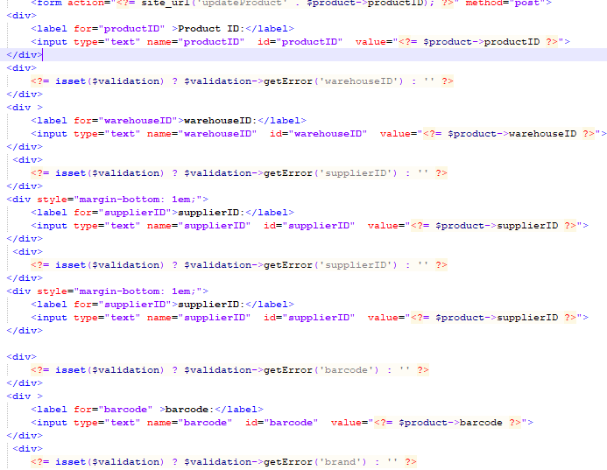

Add Staff (Luke Henley)

Once the correct data has been inserted, staff members are empowered to submit the new staff information. Following submission, they gain immediate access to the details, providing them with the option to either update the information at a later time or delete it altogether.

This post-submission functionality ensures a comprehensive staff management system, enabling staff members to seamlessly add, review, and modify staff details as needed. The dual capability to update or delete offers flexibility and control over staff information, contributing to an efficient and user-friendly staff management experience.

Update Staff (Luke Kelly)

This is the update sample data for the staff called Luke as it can be seen, we changed the last name to Price which before was Kelly to see if it will update or not.

Delete Staff (Luke kelly)

After the delete button has been pressed the staff Luke has been successfully deleted

Add Category (Ciaran)

Admin can initiate the process of adding a new category by clicking on the "Add Category" button. This action directs them to a dedicated form where they input the necessary data. After completing and submitting the form, the system facilitates a seamless transition, returning users to the table view. Here, they can immediately witness the successful addition of the new category, now visible within the table.

This user-friendly workflow ensures a straightforward and intuitive experience for adding categories. The systematic integration of the form submission and table update offers users real-time confirmation, allowing them to easily track and verify that their newly added category has been successfully included in the system.

Delete Category (Ciaran)

The administrator will have the option to delete a product. Upon selecting the delete button, a confirmation message will appear, prompting the administrator to confirm whether they are sure they want to proceed with the deletion. Once the administrator confirms the deletion, the product will be removed, and the table will be updated to reflect the absence of the deleted product.

Update Category (Ciaran)

Admin have the capability to click the "update" button associated with a pre-existing category, enabling them to edit the existing data within that category. Upon submitting the updated information through the form, the system seamlessly redirects them back to the table. This immediate redirection allows admin to observe that the update has successfully gone through, and the changes are reflected in the updated data displayed in the table.

This streamlined process ensures that admins can efficiently manage and modify category information. The transparent feedback loop, facilitated by the redirect and table update, enhances user confidence, providing a real-time confirmation that their edits have been successfully implemented

In this scenario, Ciaran, acting as an administrator, initiated a modification by changing the category name from "electric guitars" to "piano." To enact this change, the admin is required to press the "update category" button. This action triggers the system to save and implement the updated category name, ensuring that the modified information is securely stored and reflected throughout the system.

The update category functionality underscores the dynamic nature of administrative tasks, allowing for seamless adjustments to category names based on evolving needs. By incorporating the "update category" mechanism, administrators like Ciaran can efficiently manage and customize category names, contributing to the overall flexibility and adaptability of the system.

Add Member (Kristers Rakstins)

Users are provided with the capability to input their first name, last name, email, phone number, password, address, town, and county into the form. Upon completing this information, they can submit the form, and the entered sample data will be seamlessly added to the members' table, facilitating a streamlined and organized storage of user details.

Update Member (Kristers)

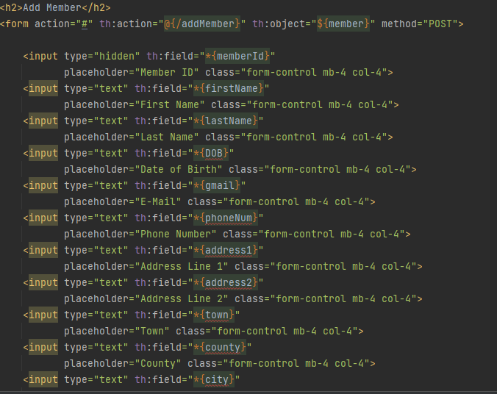The "Update Member" feature empowers users to click on the update button, allowing them to effortlessly type in new information they wish to add. Following the input of new details, users can submit the form, triggering an automatic update in the table. This straightforward process ensures that users can efficiently and dynamically modify their information, contributing to a responsive and user-friendly member management system.

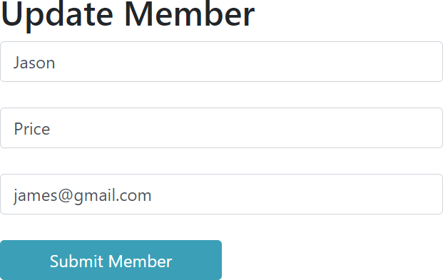

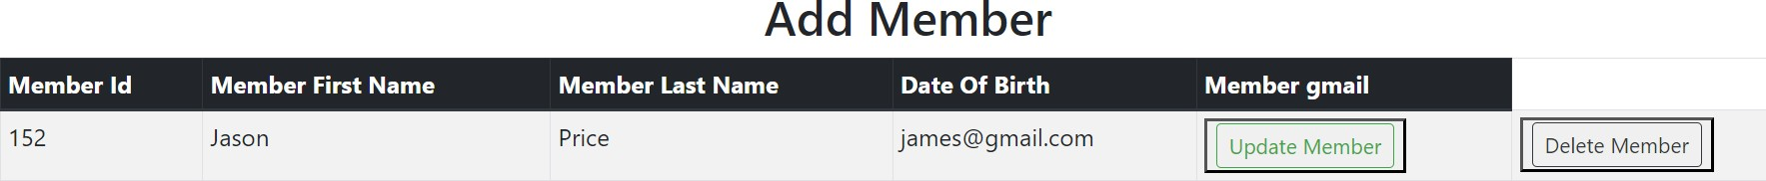

Delete Member (Kristers)

In the context of the "Remove Member" functionality, users can access the member table and select from the available options of either updating or removing a member. If they choose the removal action, a straightforward click of the button will promptly eliminate the selected member from the system. This simplified process guarantees that users can effectively handle member data effortlessly, streamlining the operation of eliminating a member from the system with a single button click.A white box with black text

Cart (Luke Henley & Ciaran)

The shopping cart functionality has been implemented to allow users to add products to their cart and proceed to checkout. This feature enhances the user experience by facilitating the convenient selection of products and a seamless transition to the checkout process. The user is granted the capability to view and manage products within the shopping cart. They can check the items currently added to the cart and proceed to checkout. Additionally, the user can easily remove products by pressing the designated 'Remove' button. Upon pressing this button, the selected product will be promptly deleted from the cart, restoring the user to the previous view of their shopping cart .Luke assumed the responsibility of developing sessions for the cart, while Ciaran undertook the responsibility of placing products into the cart.

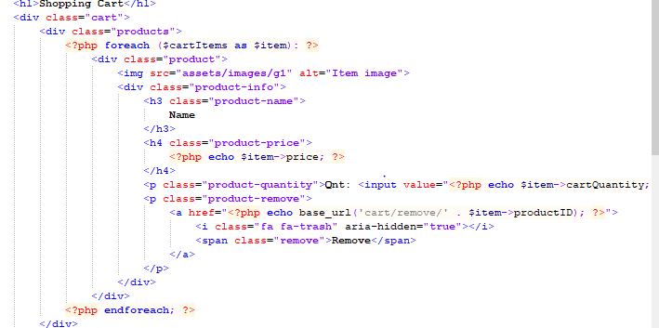

Here is some test data implemented

Logout(Kristers)

The logout function enables both users and administrators to log out of their respective accounts.

